Problem 1: load the lung dataset from the ISwR package
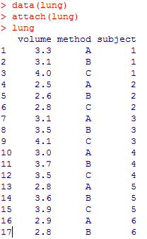
The lung data frame has 18 rows and 3 columns. It contains data on three different methods of determining human lung volume.
Variables:
volume : a numeric vector, measured lung volume.
method : a factor with levels A, B, and C.
subject : a factor with levels 1–6.

Develop R commands (script file) to determine if there are any differences in mean lung volume between the method or subjects. Make sure to first describe the data numerically and graphically, before running the appropriate analyses. Check any necessary assumptions and write a thorough conclusion of the results (Word document)

ANSWER:

> library(ISwR)

Attaching package: ‘ISwR’

The following object is masked _by_ ‘.GlobalEnv’:

juul

Warning message:
package ‘ISwR’ was built under R version 3.2.5

> data(lung)
> lungHW9 <- lung
> attach(lungHW9)
> lungHW9
volume method subject
1 3.3 A 1
2 3.1 B 1
3 4.0 C 1
4 2.5 A 2
5 2.6 B 2
6 2.8 C 2
7 3.1 A 3
8 3.5 B 3
9 4.1 C 3
10 3.0 A 4
11 3.7 B 4
12 3.5 C 4
13 2.8 A 5
14 3.6 B 5
15 3.9 C 5
16 2.9 A 6
17 2.8 B 6
18 2.9 C 6

> by(volume, subject, summary)
subject: 1
Min. 1st Qu. Median Mean 3rd Qu. Max.
3.100 3.200 3.300 3.467 3.650 4.000
------------------------------------------------------------------------------
subject: 2
Min. 1st Qu. Median Mean 3rd Qu. Max.
2.500 2.550 2.600 2.633 2.700 2.800
------------------------------------------------------------------------------
subject: 3
Min. 1st Qu. Median Mean 3rd Qu. Max.
3.100 3.300 3.500 3.567 3.800 4.100
------------------------------------------------------------------------------
subject: 4
Min. 1st Qu. Median Mean 3rd Qu. Max.
3.00 3.25 3.50 3.40 3.60 3.70
------------------------------------------------------------------------------
subject: 5
Min. 1st Qu. Median Mean 3rd Qu. Max.
2.800 3.200 3.600 3.433 3.750 3.900
------------------------------------------------------------------------------
subject: 6
Min. 1st Qu. Median Mean 3rd Qu. Max.
2.800 2.850 2.900 2.867 2.900 2.900

> by(volume, method, summary)
method: A
Min. 1st Qu. Median Mean 3rd Qu. Max.
2.500 2.825 2.950 2.933 3.075 3.300
------------------------------------------------------------------------------
method: B
Min. 1st Qu. Median Mean 3rd Qu. Max.
2.600 2.875 3.300 3.217 3.575 3.700
------------------------------------------------------------------------------
method: C
Min. 1st Qu. Median Mean 3rd Qu. Max.
2.800 3.050 3.700 3.533 3.975 4.100

> boxplot(volume~subject,data=lungHW9, main="Boxplot of Test Subject vs. Lung volume", xlab="Test Subject Number",ylab="Lung Volume")

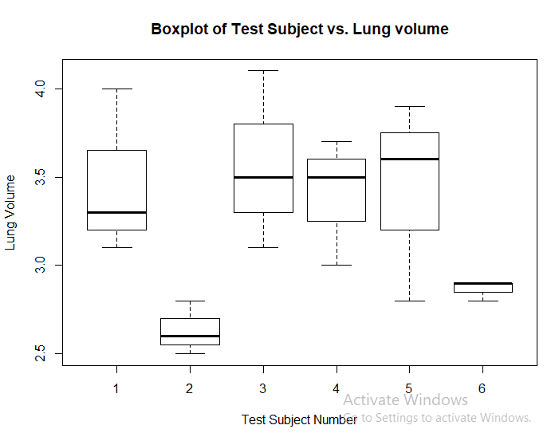

The boxplot shows that test subject 2 and 6 have very small lung volume size while other subjects are average wise close to each other.

> boxplot(volume~method,data=lungHW9,main="Boxplot of Test Method vs. Lung volume", xlab="Test Method",ylab="Lung Volume")

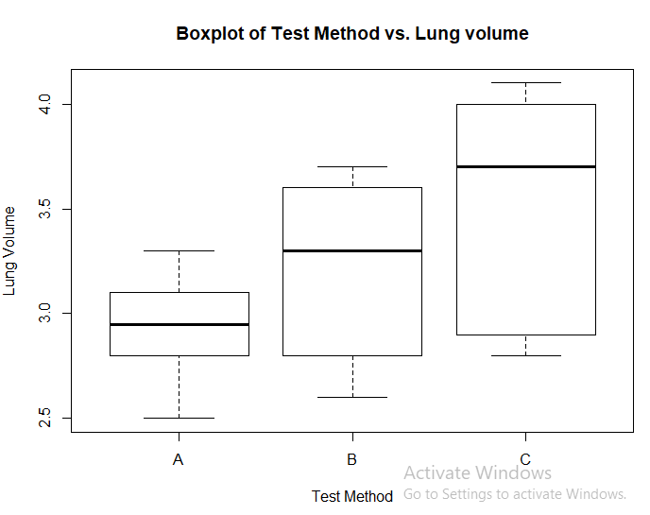
This box plot tells that method A subjects have small size of lung volume while method C subjects have bigger size of lung volume compared to subjects in other two methods.
We assume the hypothesis as follows to check if iteraction exists between method of test and test subjects,
H₀ : Factors of Subject and Method do not interact to affect the mean responses
H₁ : Factors of Subject and Method do interact to affect the mean responses
> lung.anova.interaction<-aov(lungHW9$volume~as.factor(lungHW9$method) +as.factor(lungHW9$subject)+as.factor(lungHW9$method)*as.factor(lungHW9$subject))
> summary(lung.anova.interaction)
Df Sum Sq Mean Sq
as.factor(lungHW9$method) 2 1.0811 0.5406
as.factor(lungHW9$subject) 5 2.1828 0.4366
as.factor(lungHW9$method):as.factor(lungHW9$subject) 10 0.8322 0.0832

From the output we can say that there is no interaction present between method of test and test subjects as interaction could not be estimated because there is only 1 observation at each combination of iteraction variables. Hence, we reject Null Hypothesis (H₀).
Therefore performing anova again without interaction and assuming as follows,
H₀ : Mean lung volume between the test method are same (ignoring the other factors)
H₁ : Mean lung volume between the test method are different for at least one factor
or
H₀ : Mean lung volume between the test Subject are same (ignoring the other factors)
H₁ : Mean lung volume between the test Subject are different for at least one factor
> lung.anova<-aov(lungHW9$volume~as.factor(lungHW9$method) +as.factor(lungHW9$subject))
> lung.anova
Call:
aov(formula = lungHW9$volume ~ as.factor(lungHW9$method) + as.factor(lungHW9$subject))

Terms:
as.factor(lungHW9$method) as.factor(lungHW9$subject) Residuals
Sum of Squares 1.0811111 2.1827778 0.8322222
Deg. of Freedom 2 5 10

Residual standard error: 0.2884826
Estimated effects may be unbalanced

> summary(lung.anova)
Df Sum Sq Mean Sq F value Pr(>F)
as.factor(lungHW9$method) 2 1.0811 0.5406 6.495 0.0156 *
as.factor(lungHW9$subject) 5 2.1828 0.4366 5.246 0.0127 *
Residuals 10 0.8322 0.0832
---
Signif. codes: 0 ‘***’ 0.001 ‘**’ 0.01 ‘*’ 0.05 ‘.’ 0.1 ‘ ’ 1

From the output we can say that, at least one test method is having different mean lung volume from the other two test methods.
And, at least one test subject is having different mean lung volume from the other five test subjects.
Hence, we reject the null hypothesis, H_{0.}
Both the variables method and subject are significant with p-values 0.0156 and 0.0127 respectively, which is less than default level of significance 0.05.
The p-value for test method is 0.0156 which indicates that the different methods are associated with different measures of lung volume.
The p-value for test subject is 0.0127 which indicates that each subject is associated with different measure of lung volume.

To check which factor level are different we perform Tukey test as follows,
> TukeyHSD(lung.anova)
Tukey multiple comparisons of means
95% family-wise confidence level

Fit: aov(formula = lungHW9$volume ~ as.factor(lungHW9$method) + as.factor(lungHW9$subject))

$`as.factor(lungHW9$method)`
diff lwr upr p adj
B-A 0.2833333 -0.1732445 0.7399112 0.2520218
C-A 0.6000000 0.1434222 1.0565778 0.0122174
C-B 0.3166667 -0.1399112 0.7732445 0.1885516

$`as.factor(lungHW9$subject)`
diff lwr upr p adj
2-1 -0.83333333 -1.65145666 -0.0152100 0.0453208
3-1 0.10000000 -0.71812333 0.9181233 0.9976751
4-1 -0.06666667 -0.88479000 0.7514567 0.9996680
5-1 -0.03333333 -0.85145666 0.7847900 0.9999891
6-1 -0.60000000 -1.41812333 0.2181233 0.1976352
3-2 0.93333333 0.11521000 1.7514567 0.0237972
4-2 0.76666667 -0.05145666 1.5847900 0.0696726
5-2 0.80000000 -0.01812333 1.6181233 0.0562068
6-2 0.23333333 -0.58479000 1.0514567 0.9108816
4-3 -0.16666667 -0.98479000 0.6514567 0.9766629
5-3 -0.13333333 -0.95145666 0.6847900 0.9912276
6-3 -0.70000000 -1.51812333 0.1181233 0.1066365
5-4 0.03333333 -0.78479000 0.8514567 0.9999891
6-4 -0.53333333 -1.35145666 0.2847900 0.2905205
6-5 -0.56666667 -1.38479000 0.2514567 0.2404375

This output indicates that the differences C-A, 2-1 and 3-2 are significant as p-value is less than level of significance 0.05, other all differences are not significant.

Now checking the anova assumptions for normality,
> plot(fitted(lung.anova),residuals(lung.anova), main = "Scatterplot for lung.anova vs. residuals of lung.anova")
> abline(h=0,col="red",lty=2,lwd=2)

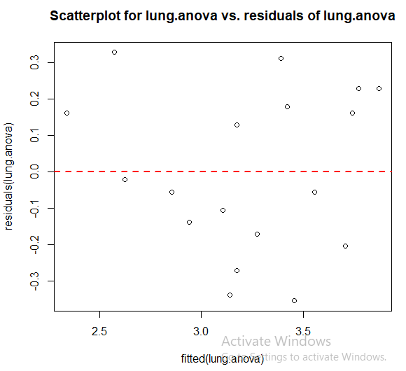
In this residual versus fits plot, the points appear randomly scattered on the plot. None of the groups appear to have substantially different variability.

> hist(residuals(lung.anova),col="light blue", xlab="Residuals of Anova", main="Histogram of Residuals for Anova")

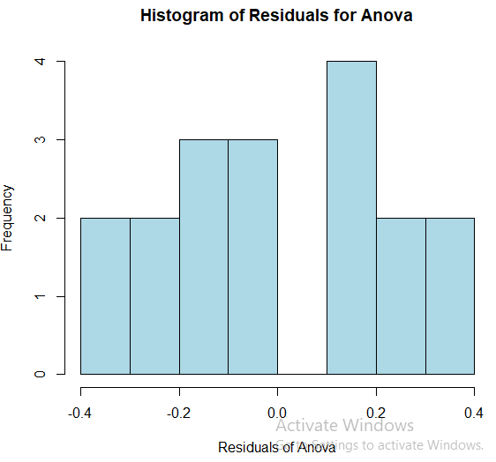
> shapiro.test(resid(lung.anova))

Shapiro-Wilk normality test

data: resid(lung.anova)
W = 0.93947, p-value = 0.2838

Observing p-value from the output we can say that the data is normally distributed and the assumptions of anova are satisfied.

Now we find the model summary,
> lung.lm<-lm(lungHW9$volume~as.factor(lungHW9$method)+as.factor(lungHW9$subject))
> summary(lung.lm)

Call:
lm(formula = lungHW9$volume ~ as.factor(lungHW9$method) + as.factor(lungHW9$subject))

Residuals:
Min 1Q Median 3Q Max
-0.35556 -0.16389 -0.03889 0.17361 0.32778

Coefficients:
Estimate Std. Error t value Pr(>|t|)
(Intercept) 3.17222 0.19232 16.494 1.4e-08 ***
as.factor(lungHW9$method)B 0.28333 0.16656 1.701 0.11975
as.factor(lungHW9$method)C 0.60000 0.16656 3.602 0.00483 **
as.factor(lungHW9$subject)2 -0.83333 0.23555 -3.538 0.00538 **
as.factor(lungHW9$subject)3 0.10000 0.23555 0.425 0.68016
as.factor(lungHW9$subject)4 -0.06667 0.23555 -0.283 0.78293
as.factor(lungHW9$subject)5 -0.03333 0.23555 -0.142 0.89027
as.factor(lungHW9$subject)6 -0.60000 0.23555 -2.547 0.02900 *
---
Signif. codes: 0 ‘***’ 0.001 ‘**’ 0.01 ‘*’ 0.05 ‘.’ 0.1 ‘ ’ 1

Residual standard error: 0.2885 on 10 degrees of freedom
Multiple R-squared: 0.7968, Adjusted R-squared: 0.6546
F-statistic: 5.603 on 7 and 10 DF, p-value: 0.00768

The adjusted R-square is 0.6546, hence we can say that subject and method of test together explain 65.46% variation in measures of lung volume.

